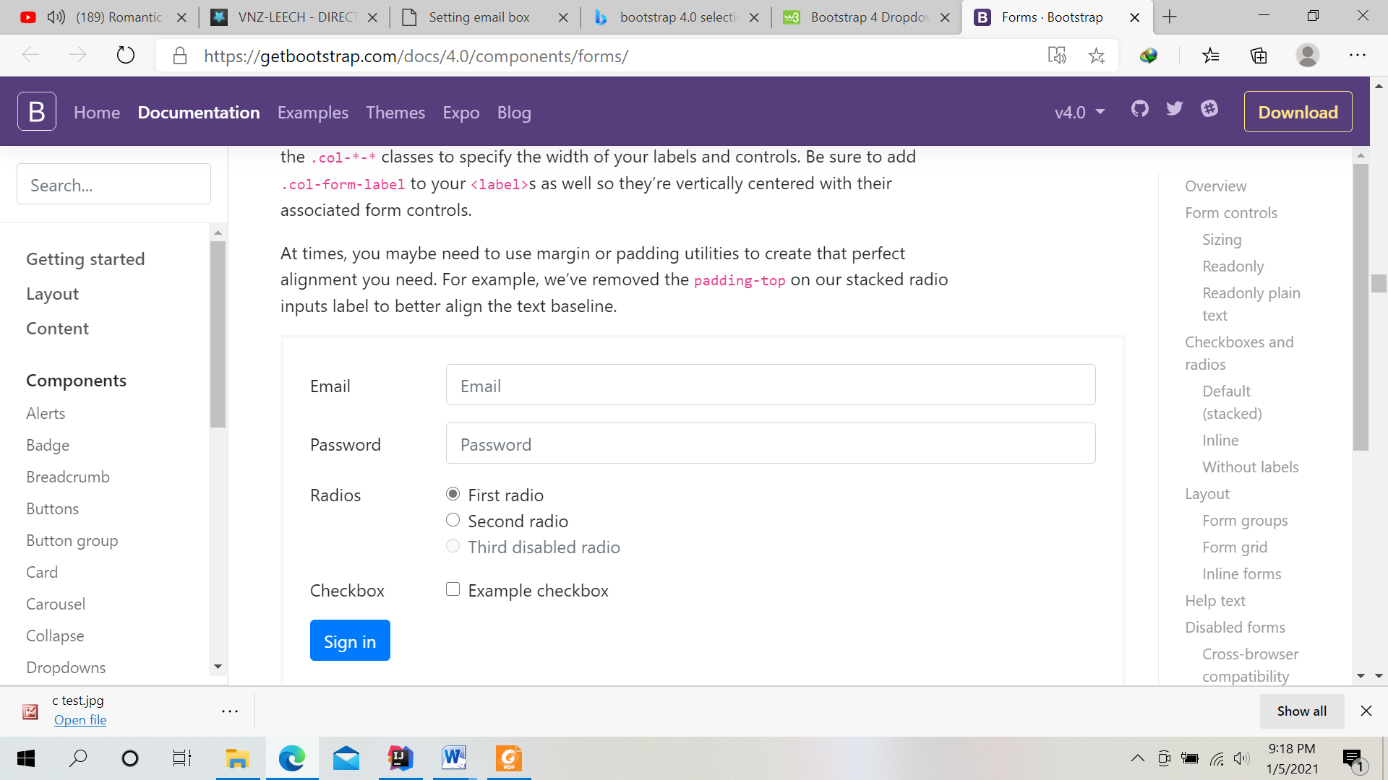

<form>

<div class="form-group row">

<label for="inputEmail3" class="col-sm-2 col-form-label">Email</label>

<div class="col-sm-10">

<input type="email" class="form-control" id="inputEmail3" placeholder="Email">

</div>

</div>

<div class="form-group row">

<label for="inputPassword3" class="col-sm-2 col-form-label">Password</label>

<div class="col-sm-10">

<input type="password" class="form-control" id="inputPassword3" placeholder="Password">

</div>

</div>

<fieldset class="form-group">

<div class="row">

<legend class="col-form-label col-sm-2 pt-0">Radios</legend>

<div class="col-sm-10">

<div class="form-check">

<input class="form-check-input" type="radio" name="gridRadios" id="gridRadios1" value="option1" checked>

<label class="form-check-label" for="gridRadios1">

First radio

</label>

</div>

<div class="form-check">

<input class="form-check-input" type="radio" name="gridRadios" id="gridRadios2" value="option2">

<label class="form-check-label" for="gridRadios2">

Second radio

</label>

</div>

<div class="form-check disabled">

<input class="form-check-input" type="radio" name="gridRadios" id="gridRadios3" value="option3" disabled>

<label class="form-check-label" for="gridRadios3">

Third disabled radio

</label>

</div>

</div>

</div>

</fieldset>

<div class="form-group row">

<div class="col-sm-2">Checkbox</div>

<div class="col-sm-10">

<div class="form-check">

<input class="form-check-input" type="checkbox" id="gridCheck1">

<label class="form-check-label" for="gridCheck1">

Example checkbox

</label>

</div>

</div>

</div>

<div class="form-group row">

<div class="col-sm-10">

<button type="submit" class="btn btn-primary">Sign in</button>

</div>

</div>

</form>